Consider the following three csv files from which you receive data sets. We want the two result set as the output from the python program / module.

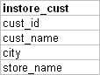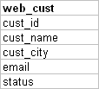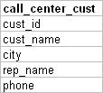

Consider the following rules while processing the data from these three data sets.

* Web cust
  + Email is a must, Email must have @,Status <> ‘Bounced’
* Call center
  + Phone number is a must, If no sales rep name reject those records
* instore_cust
  + Store name is a must
* Priority of selection (1.Instore, 2.Call center 3.Web). If the same customer exists in instore and call center, then use the information in instore to populate the target table.
* The Unique key to identify the duplicate is cust_name and city. (cust_name and city)
* **Target dataset (customer360.csv)**

CUST_ID   
SRC_CUST_ID   
CUST_NAME   
CITY   
EMAIL  
PHONE  
REP_NAME  
SOURCE (Valid values are WEB, CAC,INS)

* **ErrorRecords dataset (customererror_records.csv)**

REJ_ID  
SRC_REC  
REASON